1. Create a report that displays EMPNO, ENAME, DEPTNO of employees who work with SCOTT. (Nested Sub Query)
Query:
SELECT EMPNO, ENAME, DEPTNO
FROM EMP
WHERE DEPTNO=(SELECT DEPTNO FROM EMP WHERE ENAME='SCOTT')
Output:
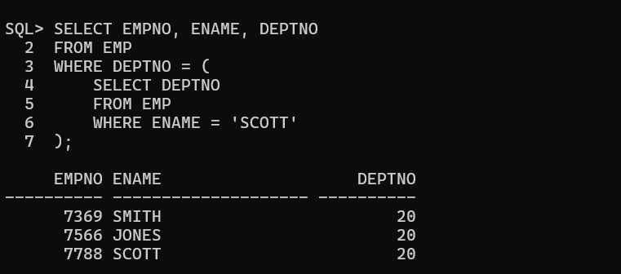

2. Display the employees who earn more than the average salary of EMP table.
Query:
SELECT * FROM EMP WHERE SAL>(SELECT AVG(SAL) FROM EMP);
Output:
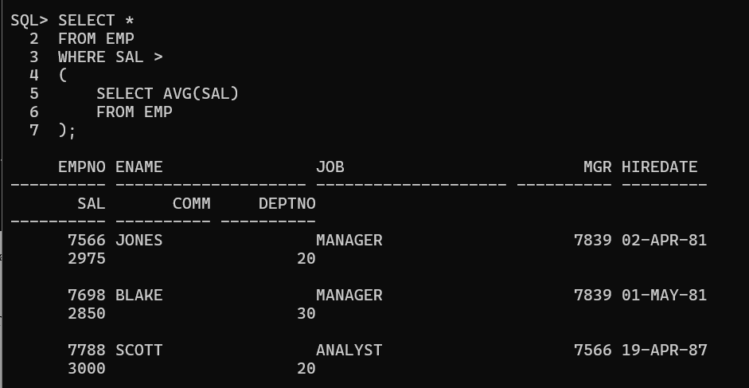
3. Display the ENAME, JOB who are Managers. (EXISTS)
Query:
SELECT E1.ENAME,E1.JOB FROM EMP E1
WHERE EXISTS (SELECT 1 FROM EMP E2 WHERE E2.MGR=E1.EMPNO);
Output:
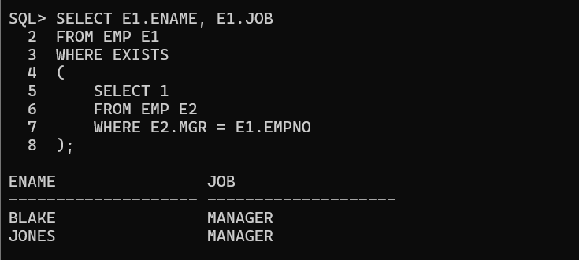
4. Display the Employees who earn less than the least salary of DEPT 10. (ALL)
Query:
SELECT * FROM EMP
WHERE SAL < ALL (SELECT SAL FROM EMP WHERE DEPTNO=10);
Output;
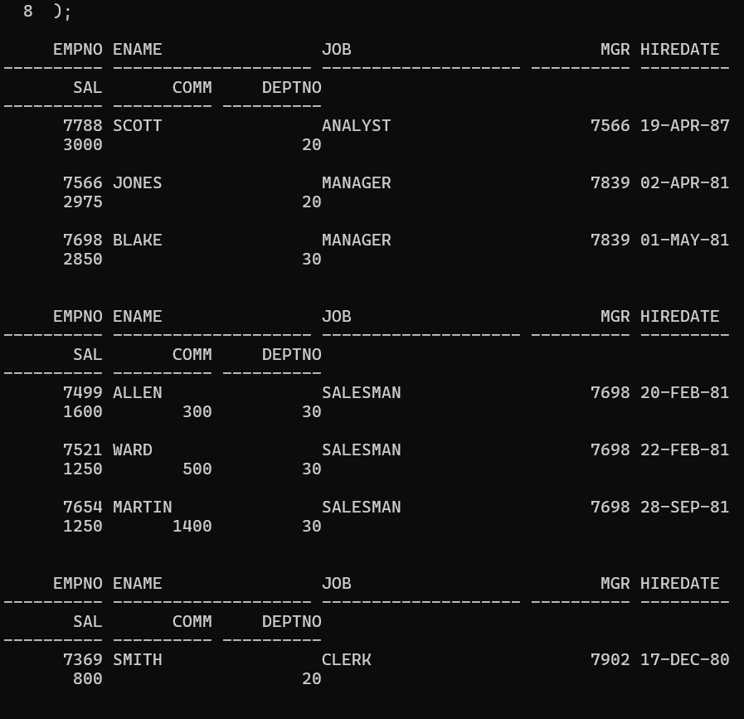

5. Display the employees who have the same DEPTNO and MGR as SCOTT excluding SCOTT.
Query:
SELECT * FROM EMP
WHERE (DEPTNO,MGR)=(SELECT DEPTNO,MGR FROM EMP WHERE ENAME='SCOTT')
AND ENAME<>'SCOTT';
Output:
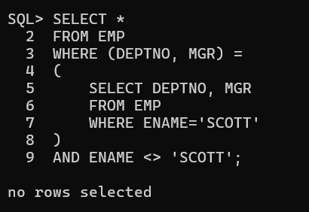

6. Write a query that displays the employee number and name of all employees who work in a department with any employee whose name contains R.
Query:
SELECT EMPNO,ENAME FROM EMP
WHERE DEPTNO IN (SELECT DEPTNO FROM EMP WHERE ENAME LIKE '%R%');
Output:
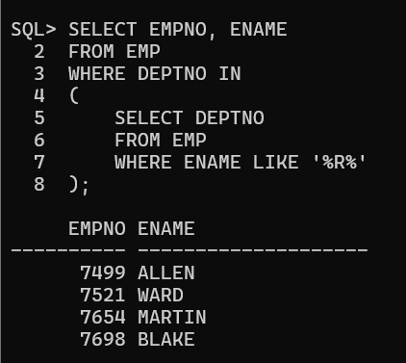
7. The HR department needs a report that displays the employee ENAME, DEPTNO, JOB of all employees whose work in NEW YORK.
Query:
SELECT ENAME,DEPTNO,JOB FROM EMP
WHERE DEPTNO=(SELECT DEPTNO FROM DEPT WHERE LOC='NEW YORK');
Output;
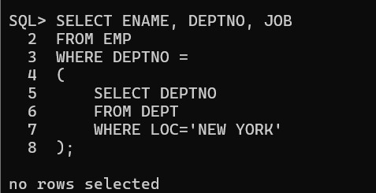
8. Modify the query so that the user is prompted for LOC.
Query:
ACCEPT LOCNAME CHAR PROMPT 'Enter Location:'
SELECT ENAME,DEPTNO,JOB FROM EMP
WHERE DEPTNO=(SELECT DEPTNO FROM DEPT WHERE LOC='&LOCNAME');
Output:
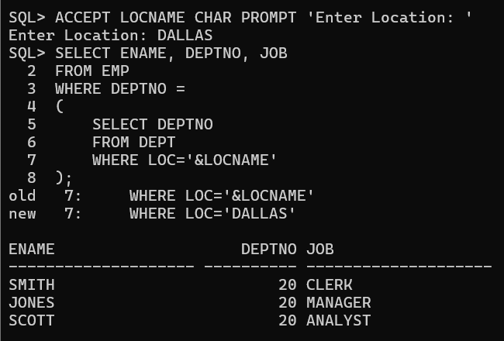

9. create a report for HR that displays the Name and salary of every employee reports to KING.
Query:
SELECT ENAME,SAL FROM EMP
WHERE MGR=(SELECT EMPNO FROM EMP WHERE ENAME='KING');
Output:
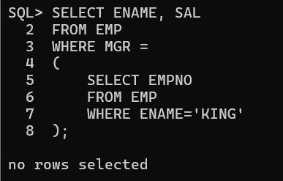
10. Write a query to display all employees working with JAMES.
Query:
SELECT * FROM EMP
WHERE DEPTNO=(SELECT DEPTNO FROM EMP WHERE ENAME='JAMES')
AND ENAME<>'JAMES';
Output:
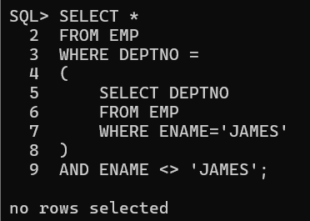

11.Displays all the employees who earn less than average salaries of their respective department.
Query:
SELECT * FROM EMP E
WHERE SAL<(SELECT AVG(SAL) FROM EMP WHERE DEPTNO=E.DEPTNO);
Output:
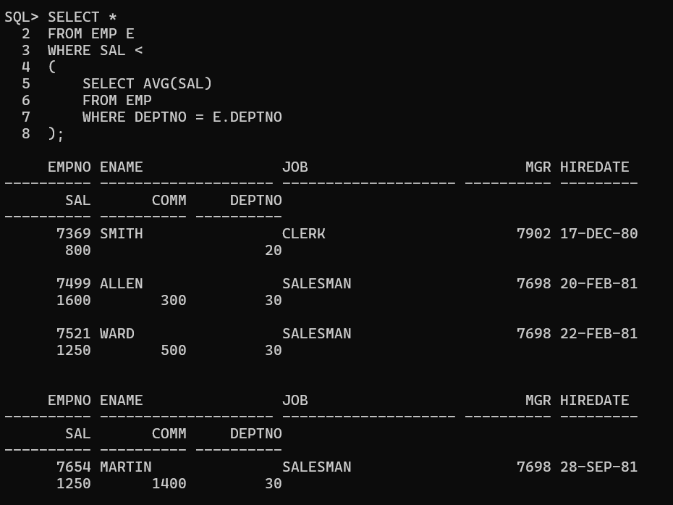

12. Write a query to display LOC and average salary of each location.
Query:
SELECT D.LOC,(SELECT AVG(SAL) FROM EMP E WHERE E.DEPTNO=D.DEPTNO) AVG_SAL
FROM DEPT D;
Output:
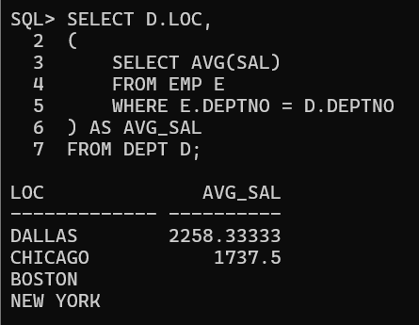

13. Write a query to display least N salaries. Use In-Line views .
Query:
SELECT * FROM (SELECT * FROM EMP ORDER BY SAL)
WHERE ROWNUM<=3;
Output:
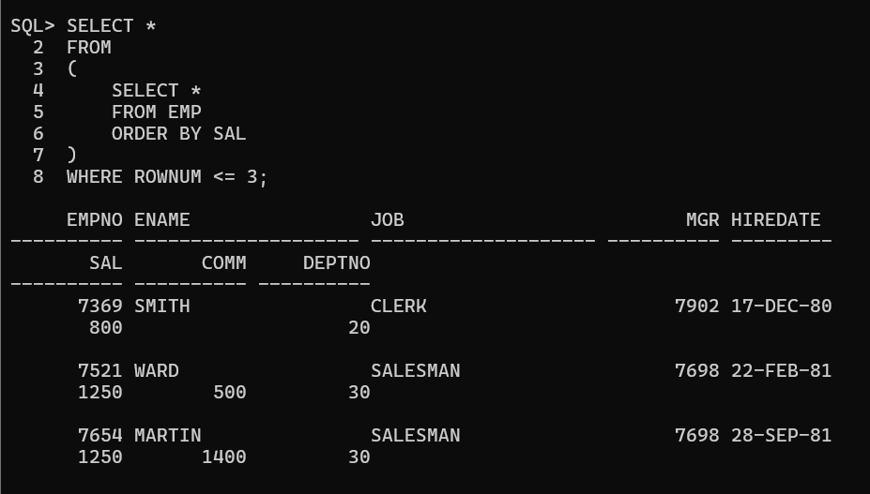

14. Display last N rows from the employees table(Use Correlated Sub Queries).
Query:
SELECT * FROM EMP E1
WHERE 3>(SELECT COUNT(*) FROM EMP E2 WHERE E2.EMPNO>E1.EMPNO);
Output:
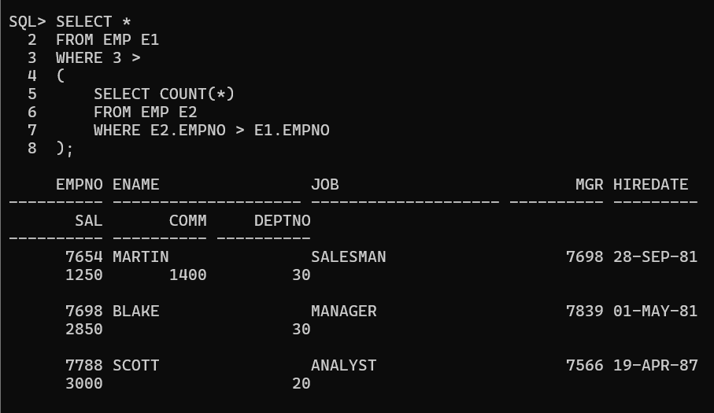

15. Display employees from employees table and sort only employees working in DALLAS.(Scalar Sub Query)
Query:
SELECT * FROM EMP
WHERE DEPTNO=(SELECT DEPTNO FROM DEPT WHERE LOC='DALLAS')
ORDER BY ENAME;
Output:
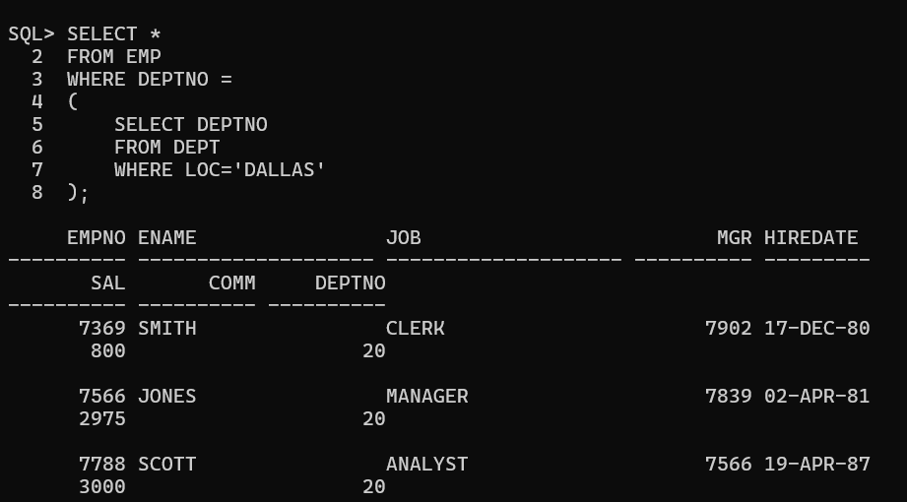

16. Display the employees who earn a salary less than avgsal of their respective department. Also display the avgsal.(Use Inline Views)
Query:
SELECT E.EMPNO,E.ENAME,E.SAL,A.AVGSAL
FROM EMP E,
(SELECT DEPTNO,AVG(SAL) AVGSAL FROM EMP GROUP BY DEPTNO) A
WHERE E.DEPTNO=A.DEPTNO AND E.SAL<A.AVGSAL;
Output:
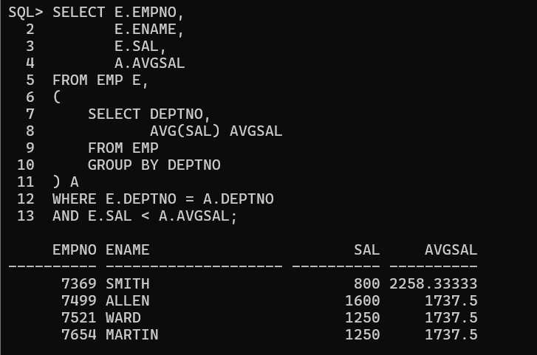

17. Write a query that display LOC of those DEPTS that have a sum of sal less than the avg sal of all the employees in DEPT table.(Use WITH Clause)
Query:
WITH DEPTSAL AS (
SELECT DEPTNO,SUM(SAL) TOTALSAL FROM EMP GROUP BY DEPTNO),
AVGEMP AS (
SELECT AVG(SAL) AVGSAL FROM EMP)
SELECT D.LOC
FROM DEPT D JOIN DEPTSAL DS ON D.DEPTNO=DS.DEPTNO
CROSS JOIN AVGEMP A
WHERE DS.TOTALSAL<A.AVGSAL;
Output:
